City Semester 13-14 Ms. Nelson

# PROBLEM SET 2-1: Curve Fitting with Linear & Quadratic Functions

For #s 1 and 2: **For more information on how to fit a linear or quadratic equation to a data set by hand, watch the following video (made by my friend Nils). Click “login as guest” on the Deerfield Moodle page.**

<https://dalearn.deerfield.edu/pluginfile.php/13674/mod_resource/content/1/Curve_Fitting_with_Linear_and_Quadratic_Functions_PPT_video_.mp4>

**y = (1000/3)(x – 1994) + 3000 y = 5(x – 155)2+ 400**

1. Find an equation of the line in 2. Find an equation of a parabola

y = a(x-h) + k form through the points. in y = a(x-h)2+k form through the points.

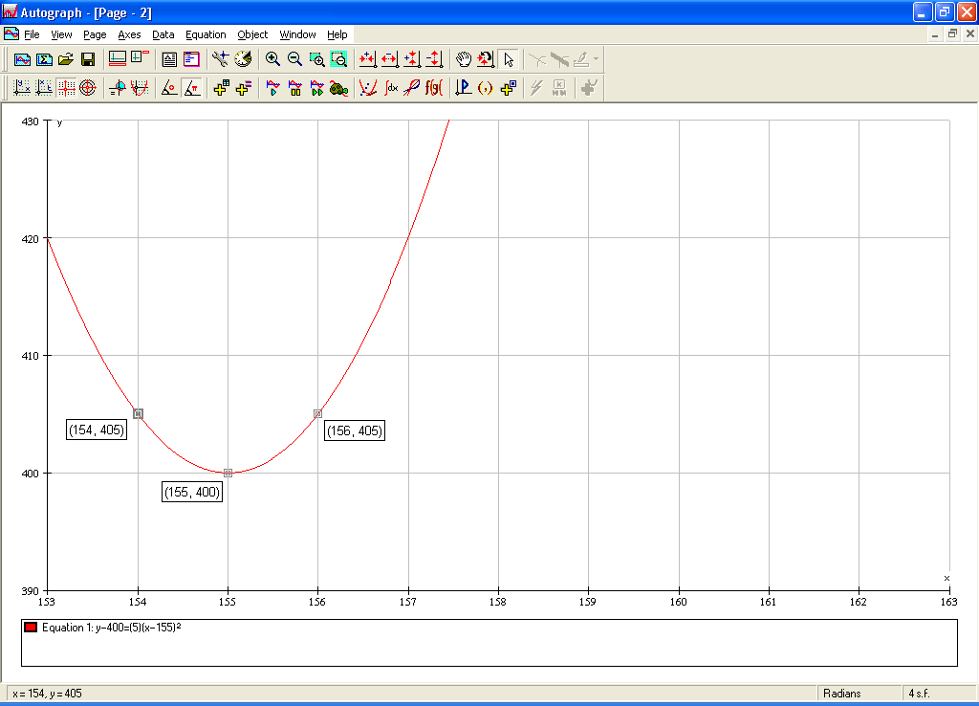  
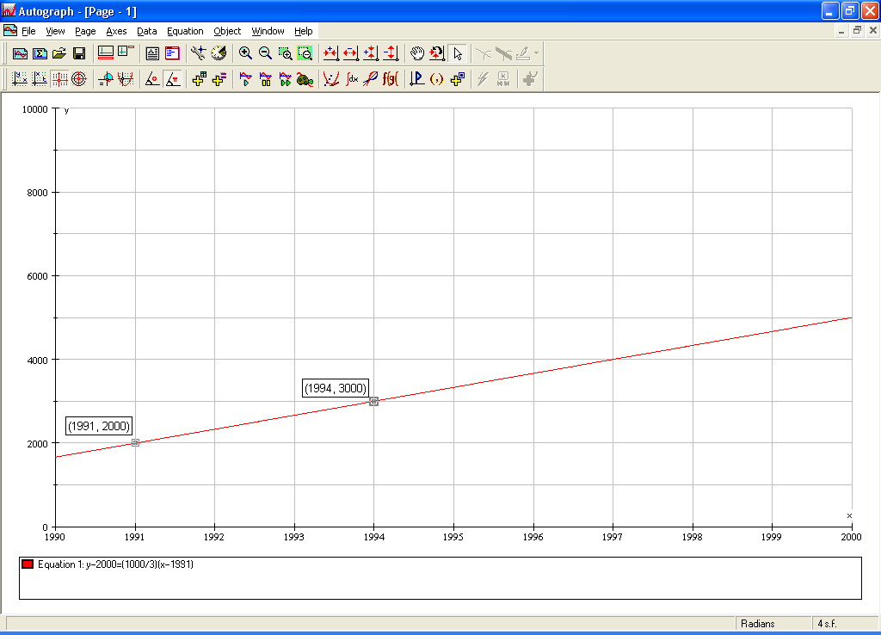

For #s 7-10: **For more information on how to fit a linear or quadratic equation to a data set in Fathom, watch the following video (also made by Nils – sorry, I know the audio is bad, turn it way up.)**

<http://www.youtube.com/watch?v=nxmXPhdclsw>

🖳 Open up “2-1-7, 8, 9, 10 (Fathom)” found in the Unit 2 Data Sets folder. For each problem, find an equation of a line [in y = a(x-h)+k form] or a parabola [in y = a(x-h)2+k form] that models the given scatterplots by following the instructions in the video. Document your work writing down the point you chose and the calculations that led to your equations.

**I know these are misnumbered…had to keep in line with the video!**

**y = -0.6(x – 0) + 2 y = 0.75(x – 99) + 25 y = 3(x + 5)2 + 10 y = -2(x – 22)2 + 20**

7. 8. 9. 10.   


Some problems courtesy of Nils Ahbel – used with permission